Citizen Portal User Guide
If this is your first time using the system. Click on the “Register” button to create your account.

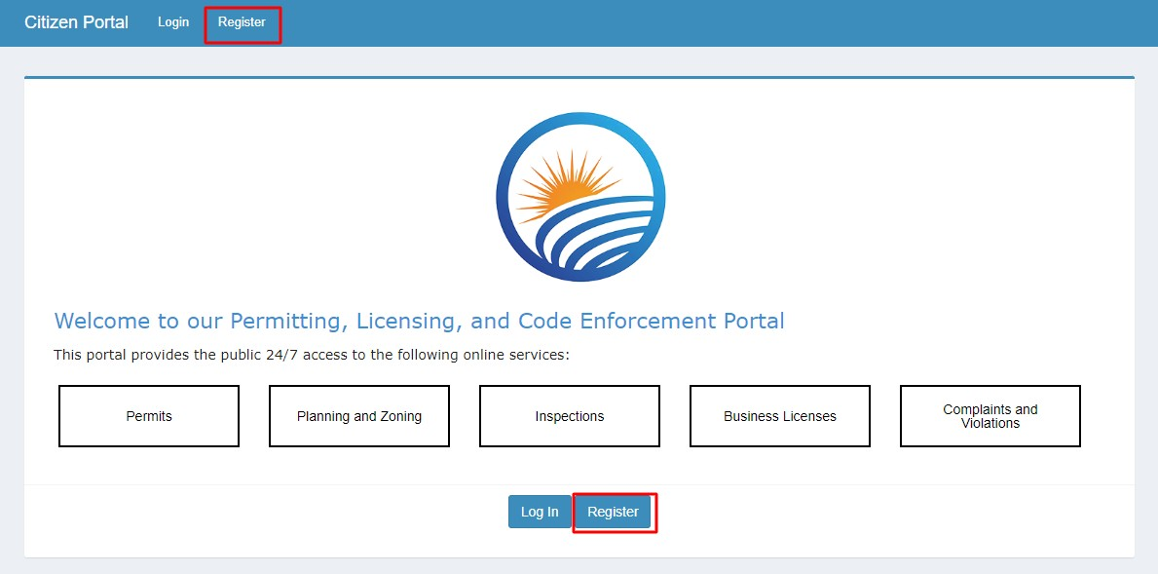
Fill out the appropriate information to create your account.
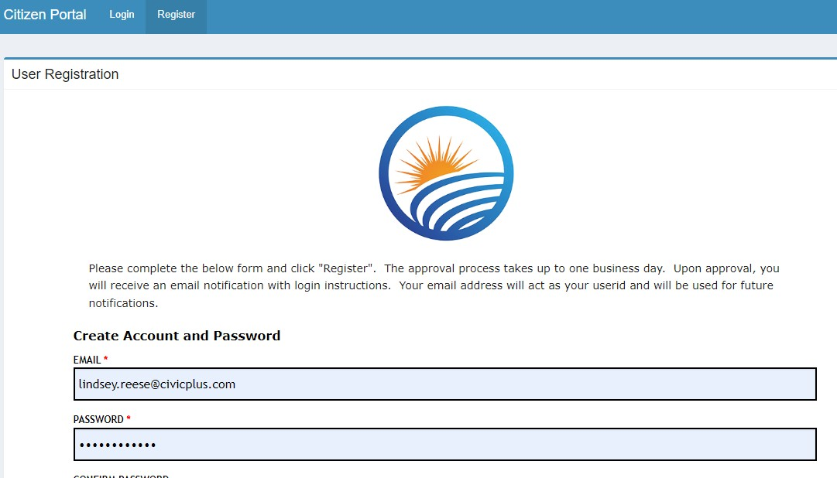
Once logged in, you will see “My Dashboard” on the left navigation. This will allow you the ability to view any of your submitted applications, status of applications and invoices.
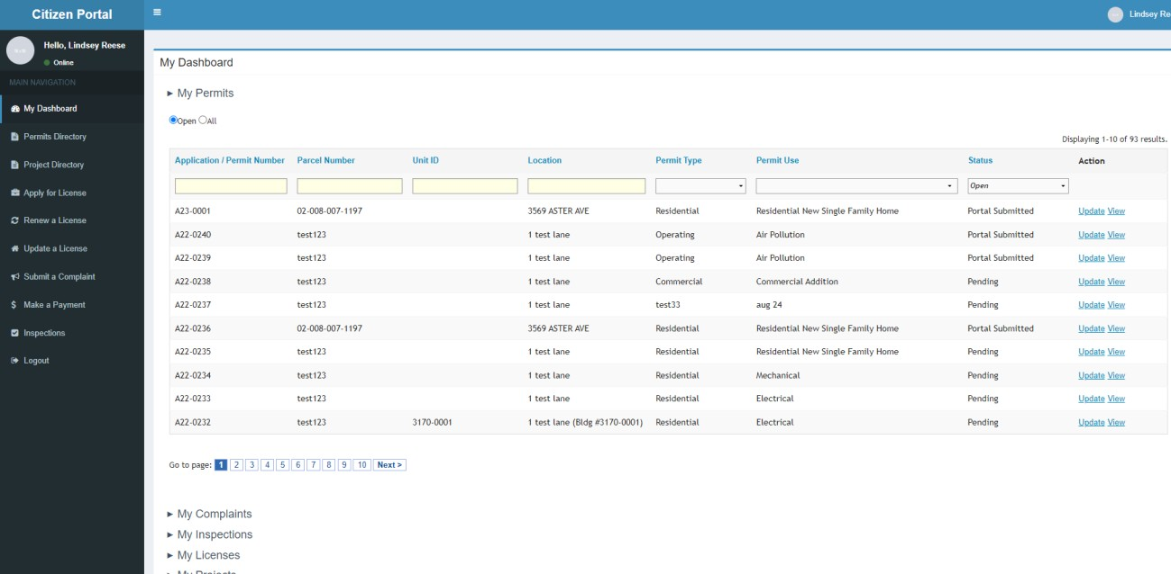
To apply for a permit or other type of service provided, click on “apply online” link connected to the type of application you want to apply.

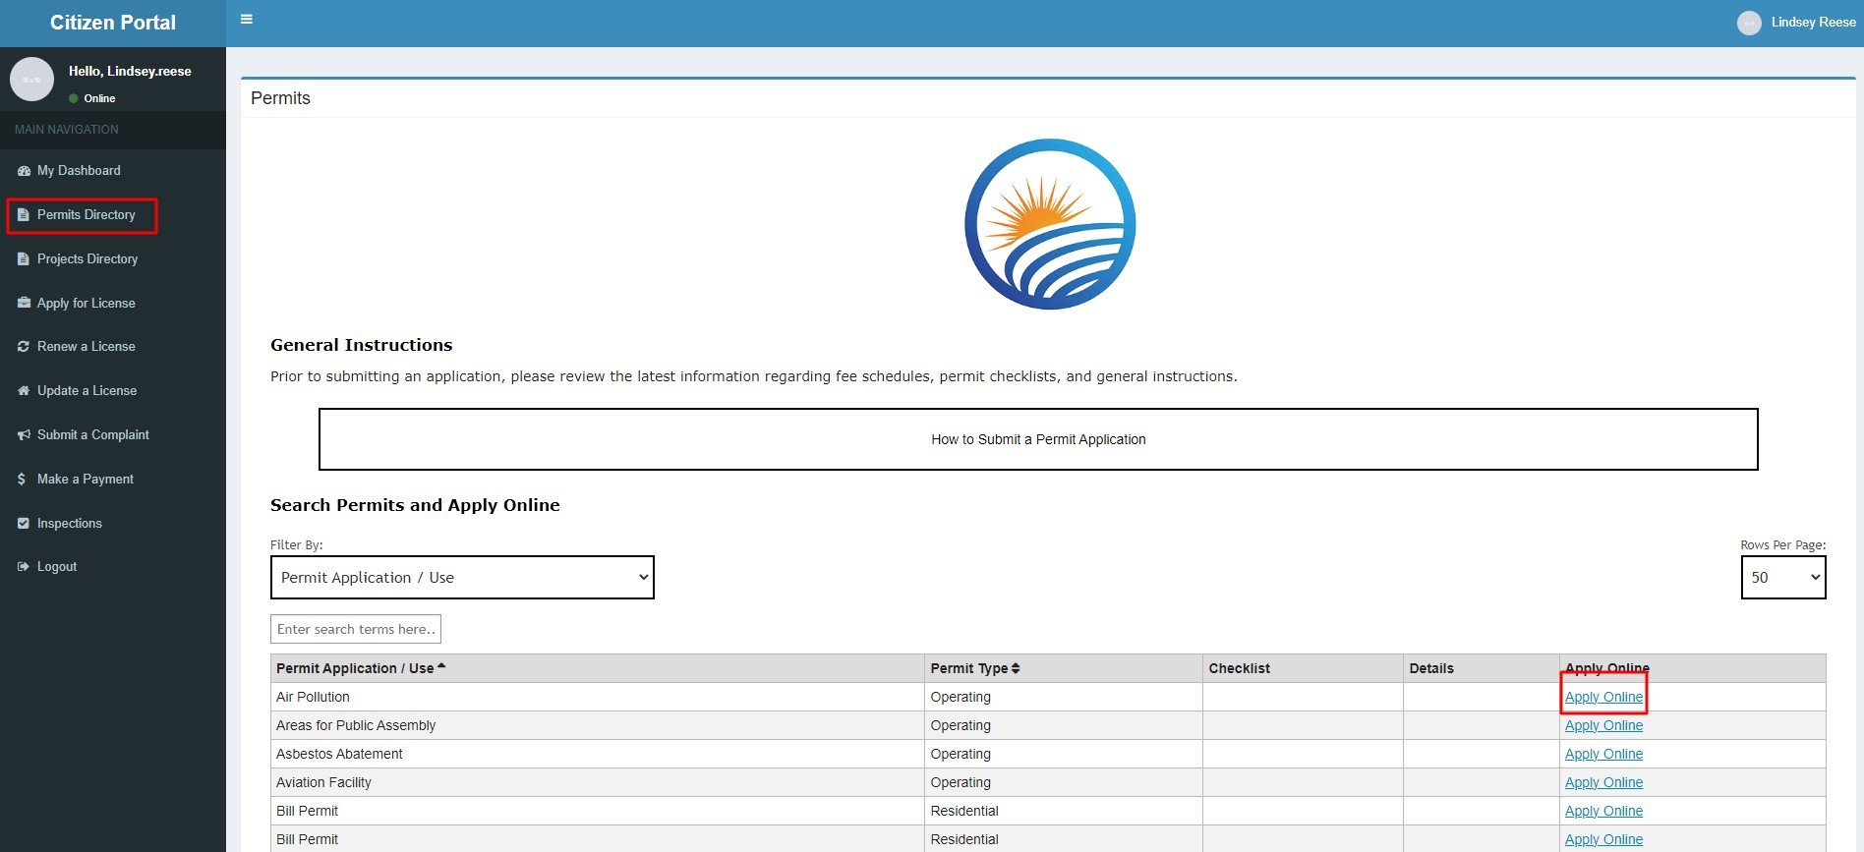
Step 1: Requires the user to identify the permit type and permit use (subtype). The type of application you choose to apply for will carry over to the application.
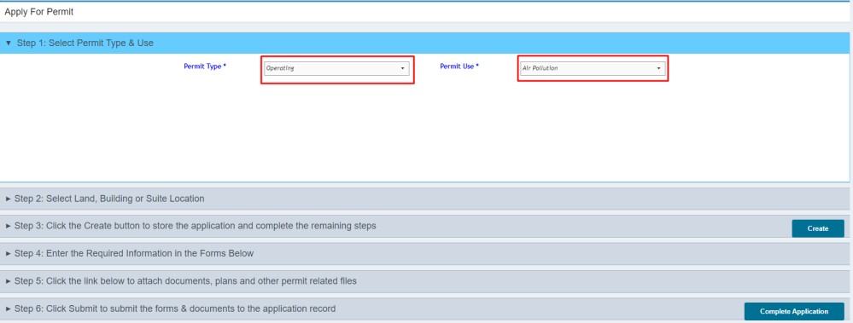
Step 2: Select the Building location or Agency Name.
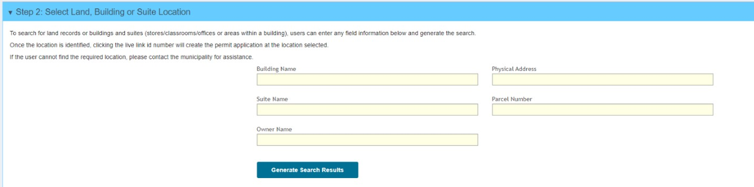

In the “physical address” field enter the address of the building. Note: Entering less of the address information is better. Example in the image below, we are searching for “395 West Street” entering 395 w would be the best way to search the building records. IF KNOWN, the applicant could search by the parcel number. Parcel Numbers can be found using Kaufman County Appraisal District’s map (https://gis.bisclient.com/kaufmancad/).
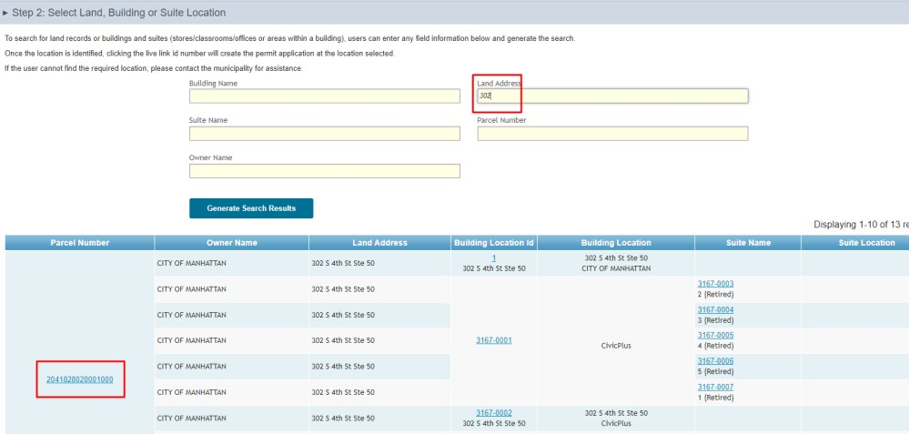

Click the “Generate Search Results” button and choose which parcel record to associate to this application by clicking on the parcel number link.
Step 3: The applicant must click the create button in step 3 to build the application and allow the remaining
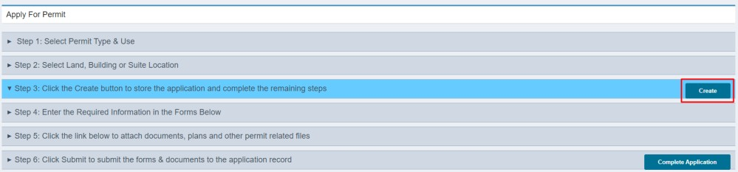
steps to be completed.
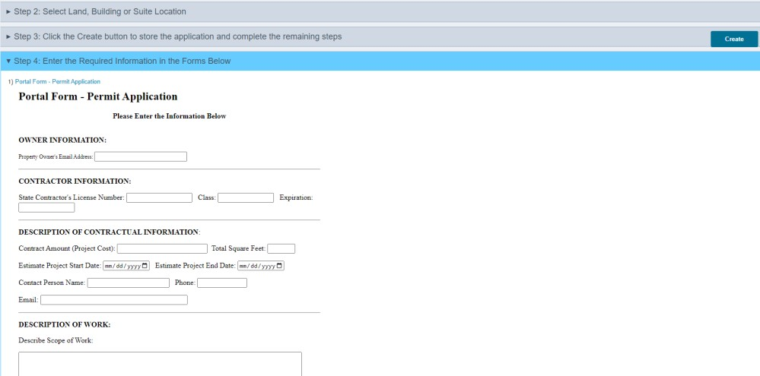

Step
4
:

Complete the fields in the portal
application form

Once the form is complete, at the bottom of the form, below the certification section is a “save” button.
The applicant must click that button, or the form will not be saved.

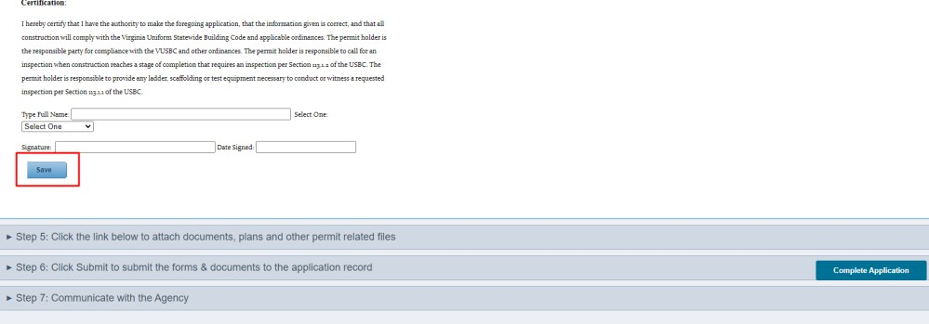
Click OK at the “Data Saved” window
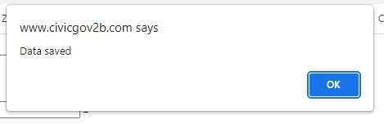
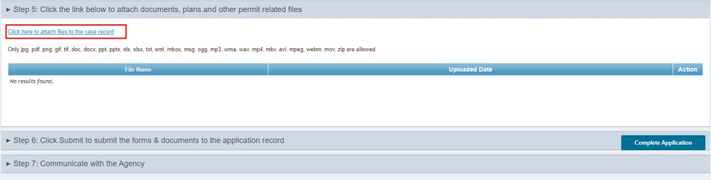
Step
5
:

Upload Documents

Step 6: Completing the Application
Click the Complete Application button. The system displays a confirmation page and the application number.
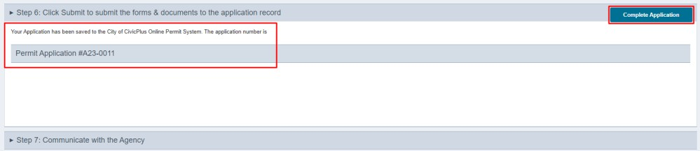

The permit submission process is complete.
Step 7: To View a Permit Previously submitted
- Login to your dashboard
- Click My Dashboard
- Click My Permits
- Search for the permit by any of the fields presented 4. Click the view link in the action column to view the permit 5. Click the Update link in the action column to:
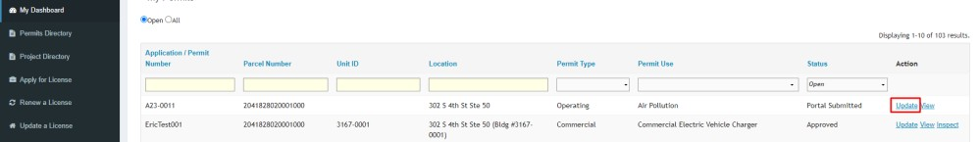
  - Update the application or,
  - Add additional documents under step 5.
6. To communicate with the Office of the State Building Inspector
- Click on Step 7
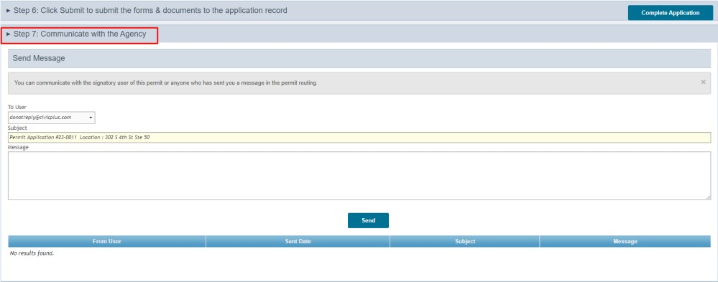
- If the permit application has not been reviewed by staff, the user will only be able to communicate with the person or department in charge of permits. Once the permit application has begun the review process, the staff assigned to review the permit application will appear in the “to user” drop down list. c. Select the staff to send the message to
d. Enter the message and Click Send

